- Meeting Date and Time: Monday, October 19, 2026
- Meeting Called to Order (time)
- Members Present/Members Absent:

  - Certificated
  - Classified
  - Parent
  - Student
  - Community
  - Administration
- Call to Order - Meeting Facilitator (time)
  - Review ground rules for meetings
  - To be read our student representatives
- Approve Minutes from Last Meeting
  - August 24, 2026
  - Approval/Second approval
- New Business
- - SSC members review and approve SCC bylaws
- - Waiver Day Vote
- - Strive HI Report
- - TSI-CU Status

- Committee Reports

- Announcements

- Pros/Cons of our Meeting

- Next SCC Meetings
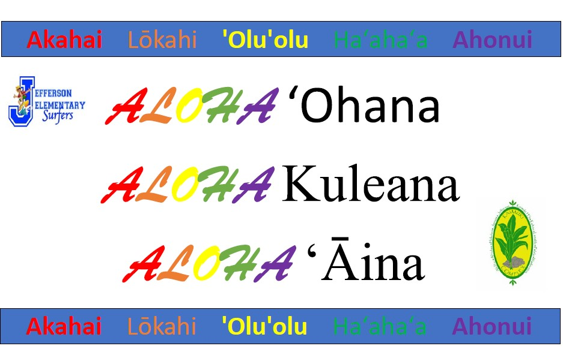

- Meeting Adjourned (time)

