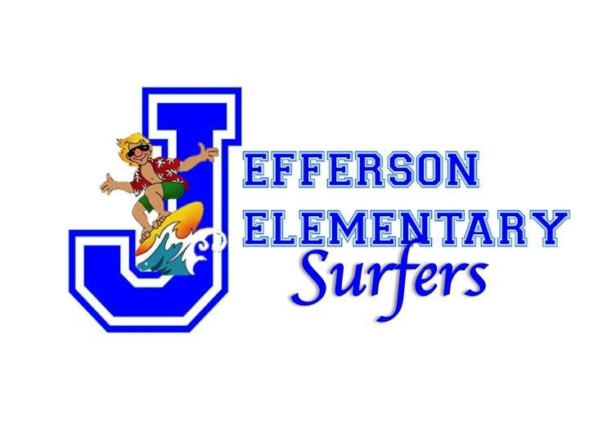
Our Family, Our Culture, Our Land

Jefferson Elementary
School Community Council (SCC) Minutes
Monday, September 25, 2023
2:30-3:30, School Library

Members Present:

Angie Morrell, Certificated
Kelly Sutcliffe, Certificated
Virginia Rose, Classified
Annie Ruby Garrett, Parent
Alston Albarado, Community

- Call to Order - 2:34p.m.

- Welcome and Mahalo to all SCC members.

- Ground Rules reviewed by Virginia: there was some discussion about changing these ground rules to those that we use for WASC. Angie suggested that we use Grammarly for our documents as a helpful tool.

- Minutes from August 21, 2023 were approved by Annie and seconded by Alston.

- SCC Timeline for this school year's meetings was shared and discussed with the committee. Roles for the chair and note-taker were made known. Will ask Jodi about a conflict of scheduling for WASC group Category D and E and our next SCC meeting on October 23, 2023. There is an overlap for Kelly and Angie to attend both.

- Committee Reports:
- Certificated:
Kelly and Angie shared that this is a WASC accreditation year and explained the WASC processes of looking for strengths and growth areas for Jefferson. This is the end of the quarter, and classes will be busy with the Genki Project again this year.
Parent-Teacher conferences begin October 30th through November 9th. School will end at 1:15 during this time, and conferences start at 1:30.
We have had Building Thinking Classrooms (Math PRIME) workshops to help students think of math in an innovative way. Last week, Dr. Liljedahl, who is an author and Olympic athlete, visited and modeled Math PRIME for our teachers. Angie shared that her student surprised her with high capabilities while problem-solving and that shy students had success.
Alston shared that on October 6th, there will be a field trip for Grades 3, 4, and 5. They will attend a play with the Honolulu Theatre for Youth called The Royal School, a history of the Hawaiian royalty who attended this school. Enrichment classes have a newsletter now that will be added to our website.

- Parents:
Annie shared that our Picture Day was great, no issues and good timing for all classes! Kelly said that parents are welcome to join the Genki Ball Project, so she might go and meet them and the class on the Ala Wai Canal.

- Certificated:
Aloha Store will open next week. SST students are doing really great, happy to have these students participate and support our school. We will be having our First Quarter Assembly on October 20th. We will acknowledge students for showing Akahai and Lōkahi, the GLO's, Great and Perfect Attendance, as well as random drawings for the ALOHA Store and Fall Challenge. There is a parent and student I will ask to join us next meeting.

- Community:
We will be partnering with the Hawaii State Foundation on Culture and the Arts. An artist from this foundation will co-teach with Kumu Alston and focus on Lokahi and the statue in the front of the school, which will be the focus of this project.

- Announcements:
Virginia - we are looking to have a food drive for WCC, sign waving with HPD, and a costume parade on October 30th.
Angie - fifth grade will create a banner for the Maui Strong Store in the library, can also display it outside of the library. They have also created a banyan tree display with messages for Maui.

- Pros - thanks to Angie and Alston for sharing and organizing school events, thanks to Annie for supporting our school and to Kelly for her hard work.
Cons - no quorum, no admin, no students.

IX. Meeting adjourned at 3:27p.m., submitted by Virginia Rose.

