- Meeting Date and Time:
- Meeting Called to Order (time)
- Members Present/Members Absent:

  - Certificated
  - Classified
  - Parent
  - Student
  - Community
  - Administration
- Call to Order - Meeting Facilitator (time)
  - Review ground rules for meetings
  - To be read by one of our student representatives
- Approve Minutes from Last Meeting
  - September 18, 2025
  - Approval/Second approval
- New Business
  - Updated JES SCC Documents (list of SCC members, SCC facilitators and note-takers
  - Chicken Updates
  - JES Picture Taking – Reflection

- Committee Reports

- Announcements

- Pros/Cons of our Meeting

- Next SCC Meetings
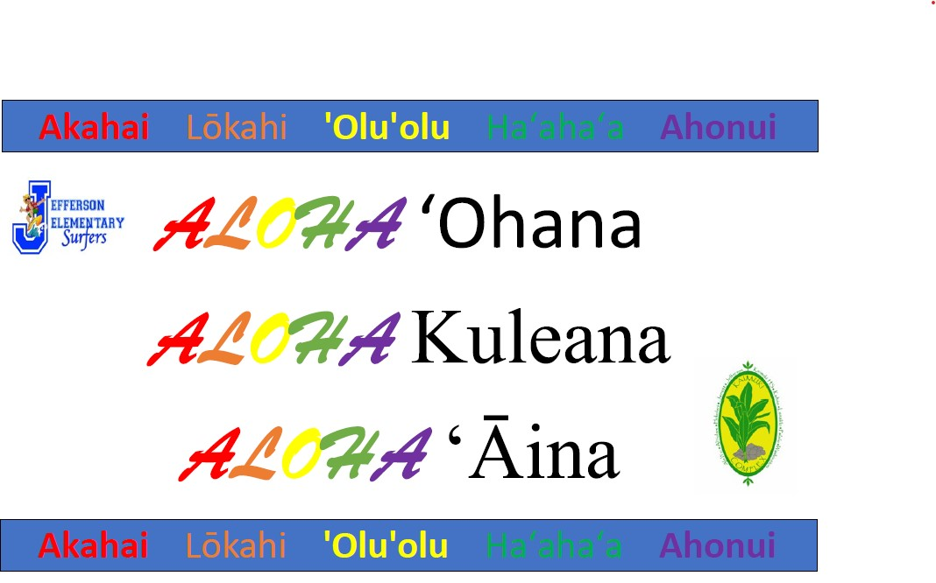

- Meeting Adjourned (time)

