- Meeting Date and Time:
- Meeting Called to Order (time)
- Members Present/Members Absent:

  - Certificated
  - Classified
  - Parent
  - Student
  - Community
  - Administration
- Call to Order - Meeting Facilitator (time)
  - Review ground rules for meetings
  - To be read by one of our student representatives
- Approve Minutes from Last Meeting
  - February 23, 2026
  - Approval/Second approval
- New Business
  - Teacher Housing Updates – informational meeting with The Wilhelm Group
  - Weather Updates – what we’ve been doing to address debris and power to our campus
  - Revisions to our Comprehensive Needs Assessment – due to new template for our 2026-2027 Academic Plan

- Committee Reports
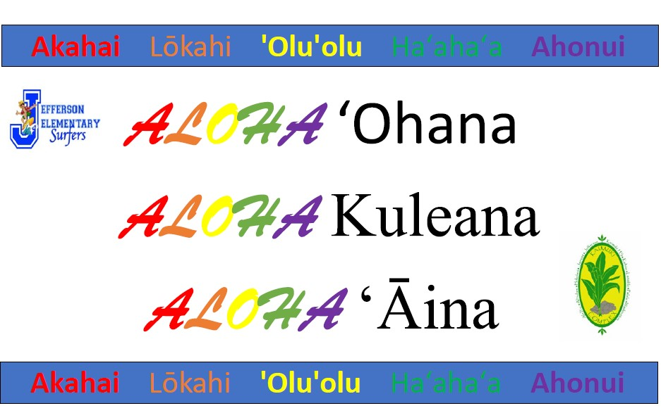

- Announcements

- Pros/Cons of our Meeting

- Next SCC Meetings

- Meeting Adjourned (time)

