- Meeting Date and Time:
Monday, August 24, 2026 (2:30PM- School Library)
- Meeting Called to Order (time)
- New Members Present and New Members Absent:

  - Certificated

  - Classified
  - Parent
  - Student
  - Community
  - Administration
- Call to Order - Meeting Facilitator (time)
  - Review ground rules for meetings
  - To be read by one of our student representatives
- Approve Minutes from Last Meeting
  - May 18, 2026
    - Approval/Second approval
- New Business
  - JES SCC Bylaws
  - 2026-2027 meeting dates and who will facilitate and record minutes
  - JES SCC members 2026-2027 (Election of officers)
- Committee Reports
- Announcements
- Pros/Cons of our Meeting
- Next SCC Meetings
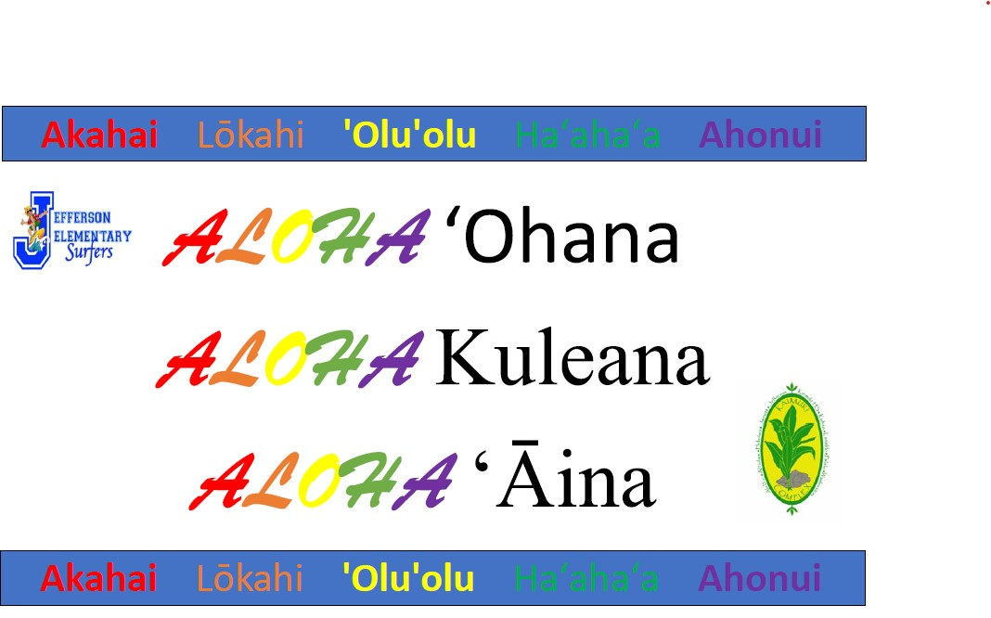
- Meeting Adjourned (time)

