- Meeting Date and Time:
- Meeting Called to Order (time)
- Members Present/Members Absent:

  - Certificated
  - Classified
  - Parent
  - Student
  - Community
  - Administration
- Call to Order - Meeting Facilitator (time)
  - Review ground rules for meetings
  - To be read by one of our student representatives
- Approve Minutes from Last Meeting
  - September 29, 2025
  - Approval/Second approval
- New Business
  - New Note-Taker/Recorder
  - STRIVE HI Reports and TSI CU (P) status
  - OHANA Eat with Me – Event #2
  - QUORUM Vote: Waiver Days for SY 2026-2027 (August 02, 2026, August 31,2026, and February 27, 2027

- Committee Reports

- Announcements

- Pros/Cons of our Meeting

- Next SCC Meetings
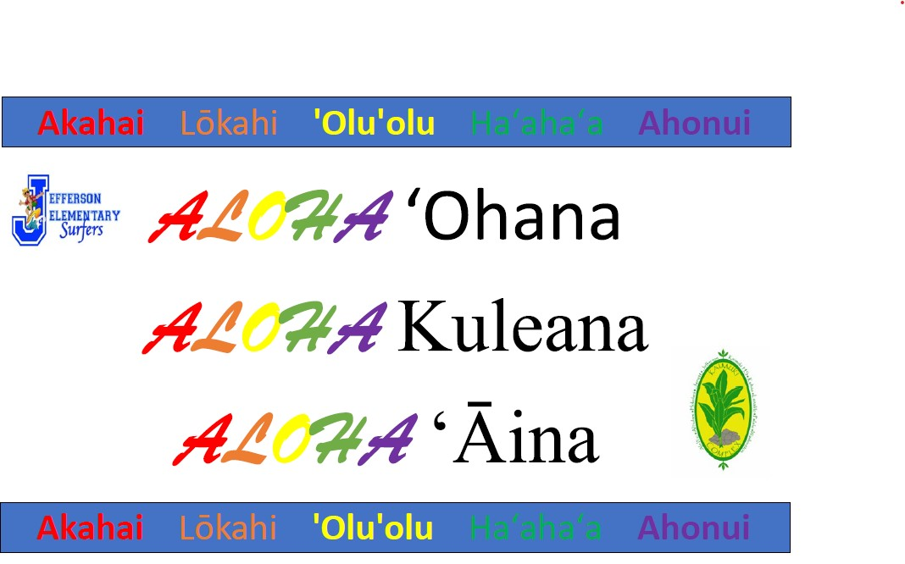

- Meeting Adjourned (time)

